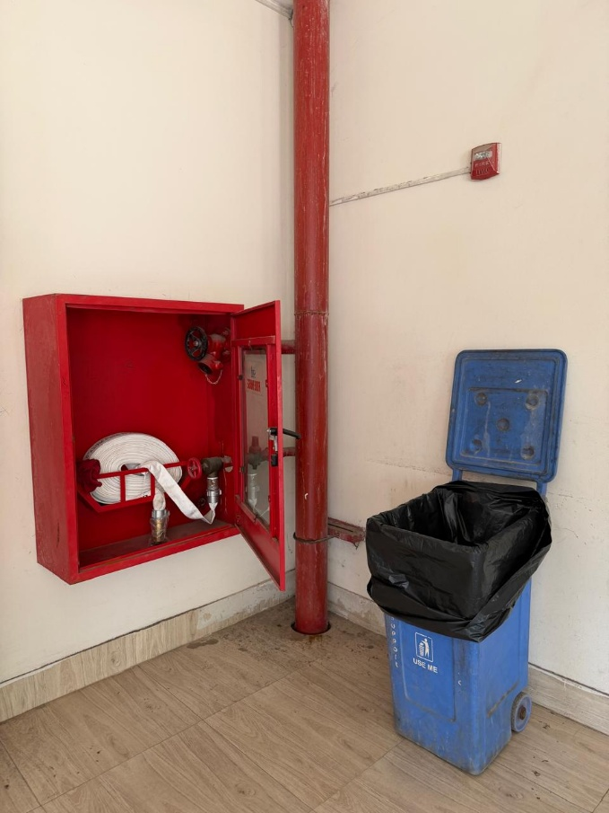
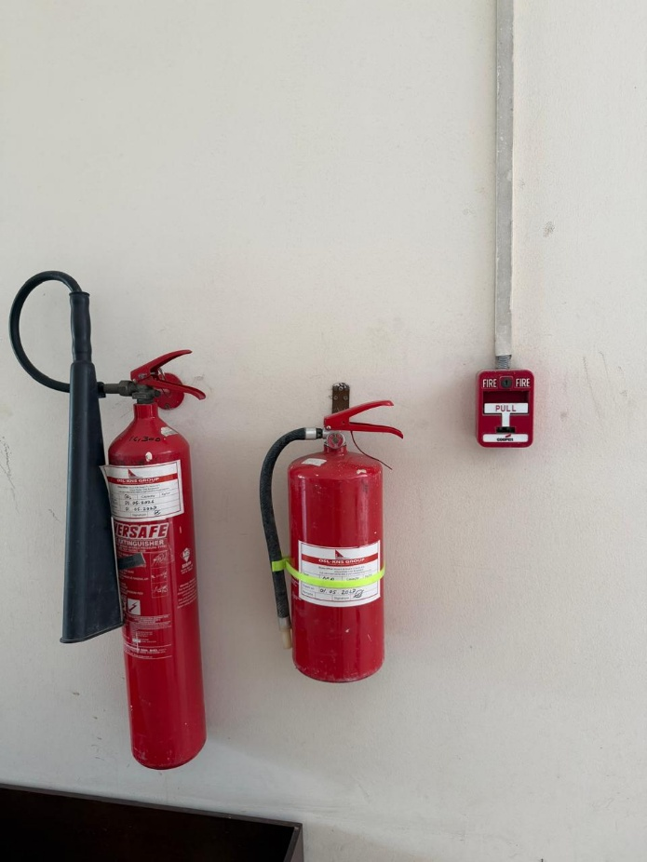
• CO₂ Fire Extinguisher: Extinguishes electrical and flammable liquid (Class B) fires without leaving chemical residue, making it safe for electronics.
• ABC Dry Chemical Extinguisher: A multipurpose unit that tackles solid combustibles (Class A), flammable liquids (Class B), and electrical fires by smothering the fuel source.
• Manual Fire Alarm Pull Station: A wall-mounted switch that occupants manually pull to activate the building's emergency evacuation alarms.
• Fire Hose Cabinet: Houses a heavy-duty water hose connected to the building's main water supply to combat larger, expanding fires before emergency services arrive.
• Fire Protection Riser: The main vertical water pipeline spanning all 14 floors, delivering high-pressure water directly to each floor's hose cabinets and sprinkler systems.

